Basic SVN start-up:

First Download tortoise SVN, if you don’t have it or some form already.

<http://tortoisesvn.net/>

Step 1:

Create a folder for Nanocon

Step 2:

Right-Click on Folder

Go to SVN Checkout

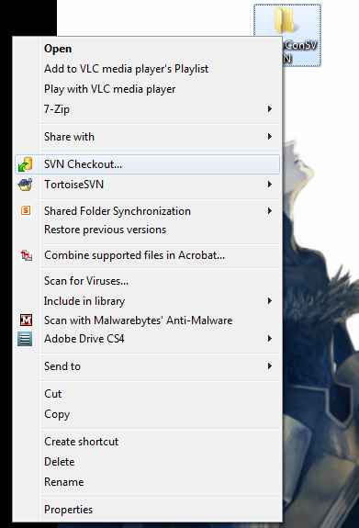

This window should appear

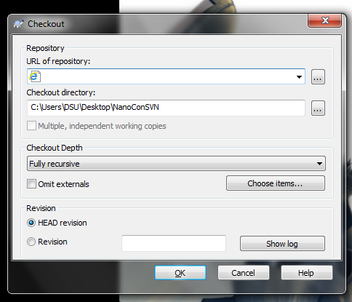

Step 3:

Type [https://svn.dsu.edu/svn/nanocon/](https://webmail.dsu.edu/owa/redir.aspx?C=zJW1TV8Pw0esIBagPE0IPJuiEz5gxdAIblPxuzxcyPyQN2a6AijThqjC12SgUlRKHN_6EeZOp04.&URL=https%3a%2f%2fsvn.dsu.edu%2fsvn%2fnanocon%2f)

Hit OK

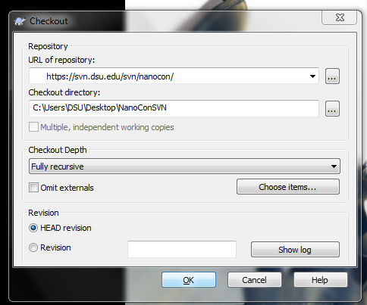

Step 4:

Type in your Credentials (default username and password to the Webmail)

Then you should be treated to this:

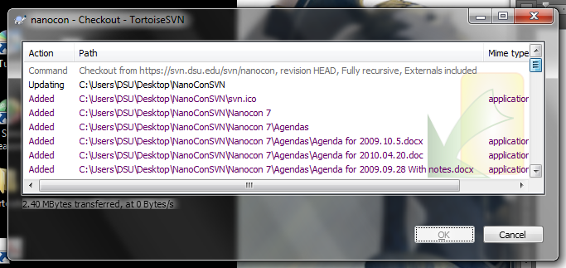

You now have the SVN access for the folder.

Step 5:

Before you commit or change any item on the SVN

Right Click SVN Update

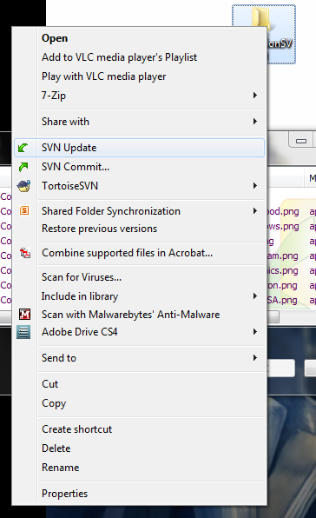

Step 6:

Updating

Right Click: SVN Commit

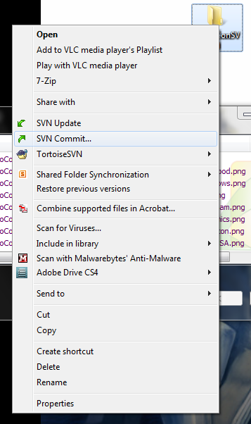

Check the Box next to what needs to be changed:

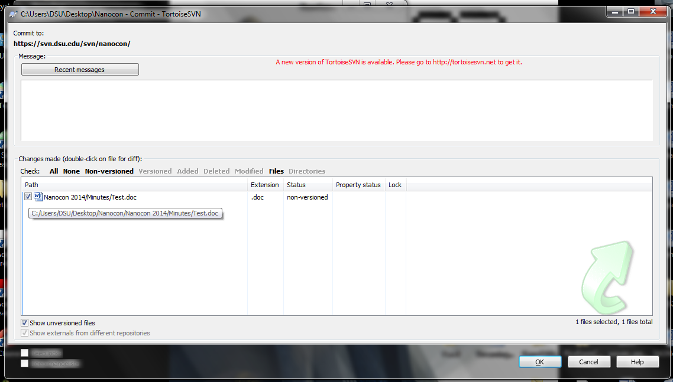

Hit Ok and your changes shall be synced.